Two-way learning from each other
An exploration in Indigenous/non-Indigenous intercultural relations
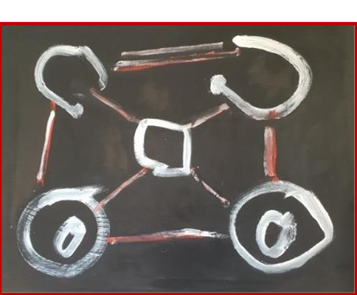

Wednesday, May 1, 2024
9am-2:30pm
National Centre of Indigenous Excellence
166-180 George Street, Redfern

(in room only event)

Program:
9am Registration and coffee
9:30am-11am Reflection around Indigenous art
11-11:30 am Morning tea
11:30-1:30pm Discussion facilitated by Craig San Roque
1:30pm -2:30pm Share lunch together
3pm (optional) Redfern walk

Background:
The Pitjantjatjara term “alpiri” refers to the time when people wake in the morning, call out to each other news from the night - thoughts, including dreams and suggestions about activity for the day.
This workshop resembles social dreaming when people come together with residues of their dreams and nascent thoughts and present them unsaturated into the group. These thoughts may not be directly interpreted but become material in the groups’ meandering conversation.
This workshop has grown out of the activities The “Two Way” Interest Group has run. The title Two Way captures the idea of a dialogue between First Nation people and non-indigenous people. It has recently become a popular idea for conversations between different cultural groups. “Two Way” is a reference to an approach offered by Hector Janadany from the East Kimberley region who saw it as his role when approaching a stranger to tell the person what they needed to hear to feel comfortable in a foreign place. He believed that if white and black fellas can get together, we can learn from each other and teach one another.
The aim of this Workshop is to encourage intercultural understanding through open dialogue. This has relevance for intercultural relations in many parts of the world.
We will use a methodology from a recent Australian Psychoanalytical Society Conference in which an indigenous artwork is presented as a stimulus for conversation. We will sit around the artwork and invite responses from the group members. We will be joined by Craig San Roque and friends who will share their stories and experiences.
Craig San Roque: “I have become attuned to bewildering dynamics and assumptions arising within intercultural relations in Australian settings - unconscious cultural complexes, misconceptions and uncertainties all included. It has been helpful to apply psychodynamic thinking when involved within the tensions of Aboriginal relations. Understanding transference processes has been helpful when attempting to unravel missed communications.”
The intention is to give us opportunities for some free and frank, ground level, sharing of experiences, tentatively and respectfully. A shared experience might strengthen understanding in handling cultural/ psychological aspects of intercultural relations- wherever these relations might arise - clinically, personally, culturally.
Facilitator:
Craig San Roque is a Jungian Analyst who been involved in Aboriginal relations throughout much of his life – including direct engagement in central Australia over the past 30 years. He is still learning from the diversities, challenge, and unexpected illuminations of that experience.
His writings and seminar events explore existential themes of Coming To Terms with the Country. These include Mourning Melancholia and the Echo Effect; (IPA, podcast), Black Knot/White Knot (seminars) and A Long Weekend in Alice Springs (award-winning graphic novel). Craig’s collaboration with the NPY Women’s Council Uti Kulinjaku/Clear Thinking project revealed how complex cultural subconscious assumptions influence black/white relations.
Craig speaks from his extensive lived experience having worked in Central Australia since 1991. This work offers him a unique understanding of the people he has lived and worked with. He shares this with us through conversations and emblematic artwork that he has been involved with to offer us an exceptional presentation.

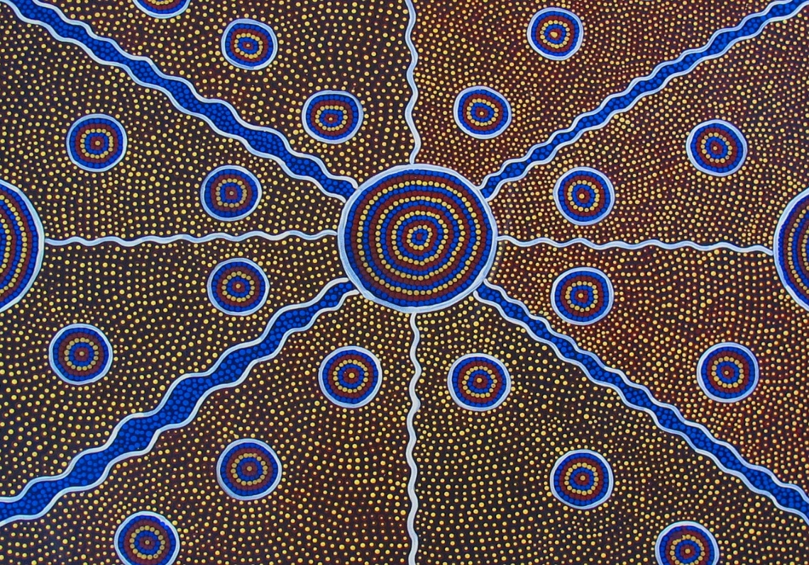

We are pleased to offer this opportunity to explore essential aspects of what it means to live in Australia.
On Behalf of the Two-Way Interest Group, Sydney Insitute of Psychoanalysis
Rise Becker, Julie Meadows, Matthew McArdle

